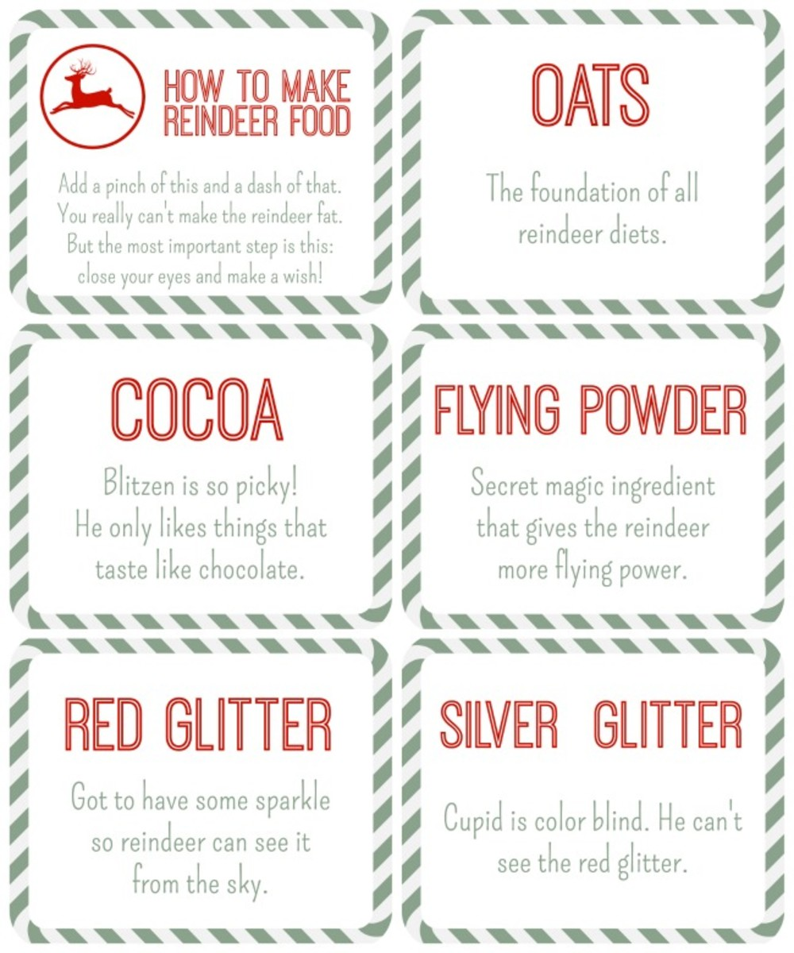

PLEASE REMEMBER TO USE ECO-CRAFT GLITTER WHICH IS MORE YUMMY THAN PLASTIC GLITTER FOR THE REINDEERS AND SAFER FOR THEM AND ENVIRONMENT TOO!