Bounce a ball 10 times to a partner.  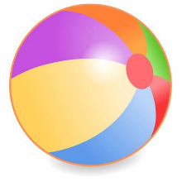 | 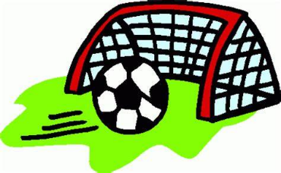  Score a goal - Kick the ball to hit the target. How many times can you score in 1 minute? | Throw and catch a ball with a partner 10 times.  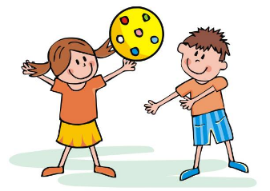 | Catch a frisbee with a partner -  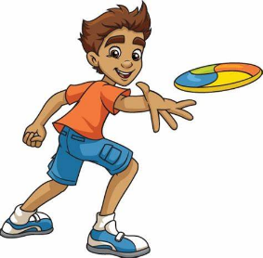  How many times can you catch in 10 throws? | Hula hoop – Can you keep your hula hoop going for the count of 10?
Skipping rope – How many jumps can you do in 1 minute? | Balancing -How long can you balance on one leg? Count as you balance. Swap legs. | 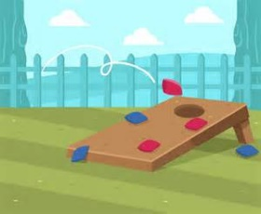  Bean bag - Throw a bean bag 10 times at a target. How many times did you hit the target? | 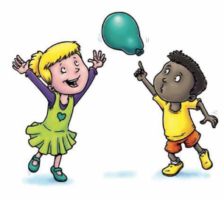  Balloon – How long can you keep a balloon off the ground for? | Jog on the spot – count to 20 as you jog on the spot.
Fitness Activities

