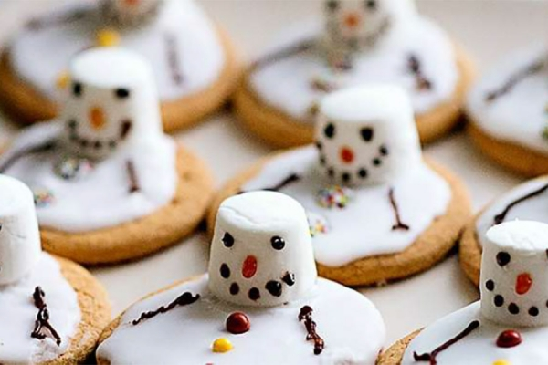

Ingredients
- 6 tbsp icing sugar
- 6 Rich Tea biscuits (or make your own biscuits)
- Edible black pen, or black writing icing
- 6 medium-sized white marshmallows
- Writing icing, for the faces and buttons (we used orange and yellow).
- Matchmaker chocolate sticks for arms
Method
- Make the icing by mixing the icing sugar with 2tbsp water in a bowl - if the mixture looks too thick, add more water. If it is too thin, add more icing sugar.
- Lay six Rich Tea or your own made biscuits on baking paper. Spoon the icing onto each biscuit, letting it ooze over the edges of the biscuit.
- Using an edible black pen, draw faces onto the marshmallows. Use orange writing icing to create the carrot nose.
- Place the marshmallows on top of each biscuit.
- Draw or add stick arms onto the icing with the edible pen or chocolate sticks. Use yellow writing icing to create the buttons.
- Leave to set or serve straight away for a melting effect.

